ADagent
Advertising Agency System

User Guide

Aug 31, 2010

This is to certify that

Mr. Kawai
Ms. Sato

Has successfully Designed & Developed
ADagent desktop application

Submitted by: Masanori Kawai, Eri Sato

Date of Issue:31/August/2010

Authorized Signature:______________

ADagent
Advertising Agency System

Welcome to ADagent!
This system is for Advertising Agency.
This user guide will introduce you to our service
and help you get smooth operations.

Contents

- Introduction
- Installation
- User Types
- System Administrator
  - User View
    - Logging in
    - Creating user accounts
    - Reference / Deleting orders
    - Editing orders
  - Fees View
    - Setting Fees
- User
  - Logging in
  - Creating new orders

1. Introduction

ADagent is a stand alone application which enable you to manage advertising project easily. You can easily refer to records of advertisement orders and overcome discrepancies in your project.

2. Installation

Expanding the submitted zip file, the below files will appear.

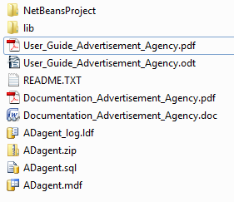

  - Attaching the database file into SQL Server
- Lunch up Microsoft SQL Server 2005 and log in user with permission of administration.
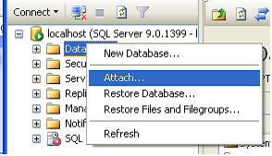

- Click add and Select the file of “ADagent.mdf”

  - Set up the connection settings in application

- Open ADagent.zip file with WinZip.

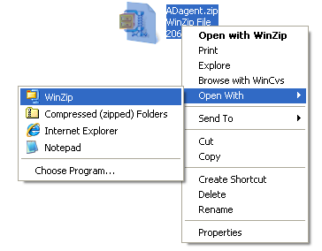

- Open persistence.xml file with Notepad.

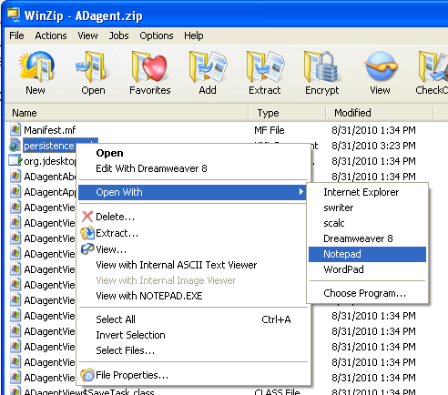

- Modify user name and password of Microsoft SQL Server 2005.

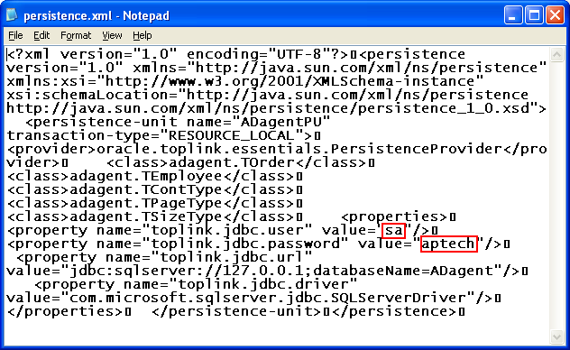
- Save the file.

- Change the file name from Adagent.zip to Adagent.jar.

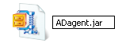
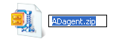
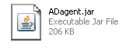

3. User Types

ADagent has two types of users:
- System Administrator
- User

System Administrator

The System Administrator can use all function within the software, as well as manage the following:
- Creating, editing and deleting User accounts
- Editing and deleting orders
- Editing the price of advertisements by setting the parameters of content type, size type and page type.

User

The user is limited to the following:
- Creating orders for customers
- Calculating total charge for advertisements automatically based on the parameter provided by the System Administer.
- Reference records of customer orders.

4. System Administrator

4.1 User View

4.1.1 Logging in

To login to Advertising Agency System as System Administrator
- Launch Advertising Agency System by double click
Adagent.jar file.
- select File > Login
- Login dialog will be displayed.
- Enter 'admin' as User name and '123' as Password.
- Click Login to open Administrator Start page.
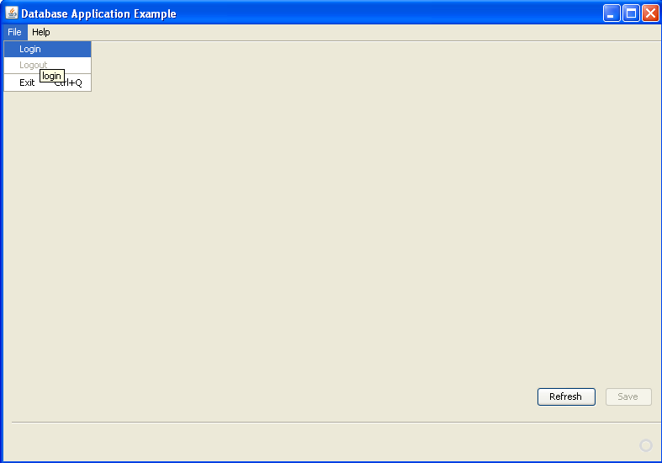
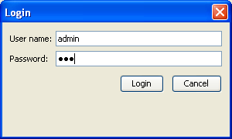
Incorrect Login Procedure

If you any reason an unrecognised combination of User name and password is used during login, the system will return an error message.
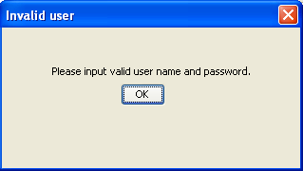
4.1.2 Creating User accounts

Having logged in successfully as a System Administrator you are now shown a new view called "User View".
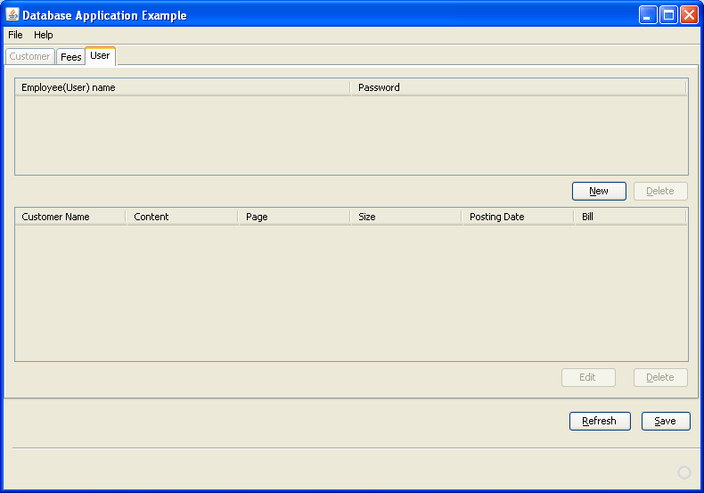
- Click New to create new user account.

- Enter Employee Name and Password on new created row.
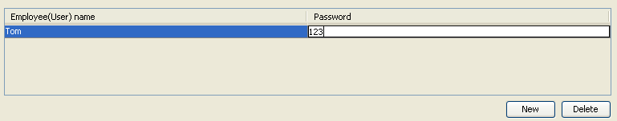
- Click Save.

Note: Data is not populated into the database unless you click Save thus if you want the initial data, click Refresh.

4.1.3 Reference / Deleting orders

The System Administrator can refer to order data* for each employee by selecting a employee on Employee list table.
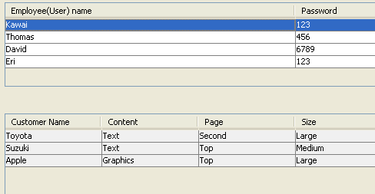
And you can also delete a selected order by clicking Delete.
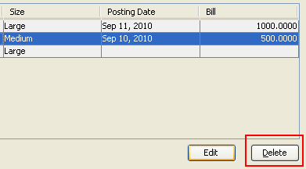
* Please refer to 5.2 Creating new Orders

4.1.4 Editing orders

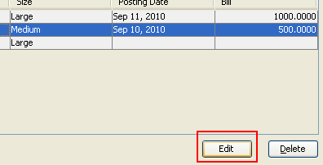
The System Administrator can edit a selected order by clicking Edit. Once you click Edit, Edit dialog will be displayed.

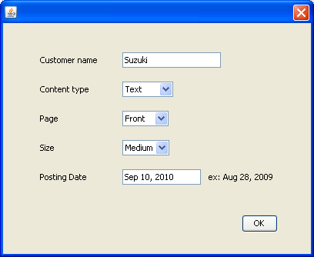
4.2 Fees View

4.2.1 Setting Fees

- Select Fees tab to desplay Fees View
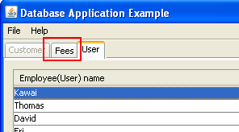
- Set the parameters of content type, size type and page type.
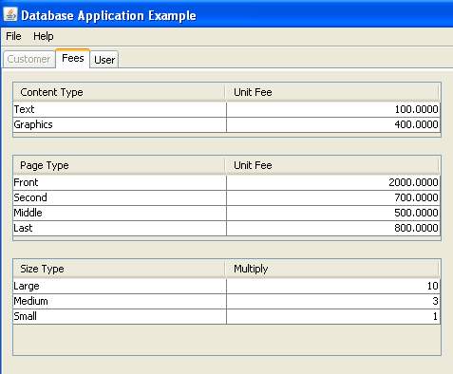

5. User

5.1 Logging in ( User )

To login to Advertising Agency System as user
- Launch Advertising Agency System by double click
Adagent.jar file.
- Select File > Login
- Login dialog will be displayed
- Enter User name and Password
- Click Login to open User Start page.

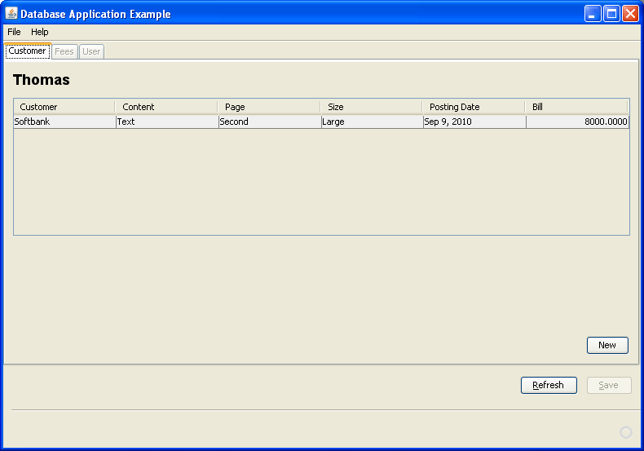
5.2 Creating New Orders

Having logged in successfully as a user you are now shown a new menu called "Customer View".

- Click New to create new order.
- Edit dialog will be displayed.
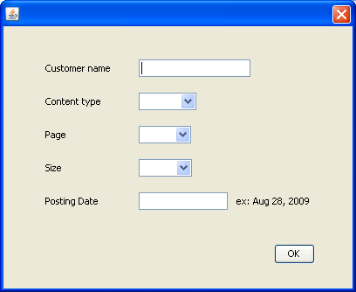
- Enter the information.
- Click Save to calculate the bill.
- You can confirm the order detail and the bill on Customer table.
- If Click Save to populate data into the database.

